Traditional Cert Only Report
OEQA Mentor/Administrator Survey 2022
June 21st 2022, 7:15 am CDT
1. The person completing this survey is:
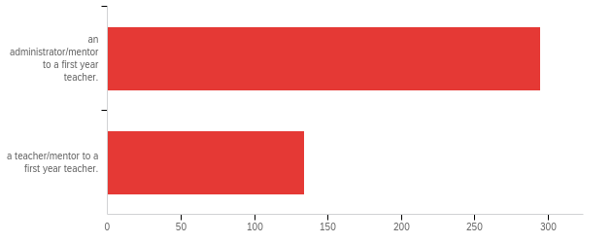

# | Answer | % | Count
1 | an administrator/mentor to a first year teacher. | 68.76% | 295
2 | a teacher/mentor to a first year teacher. | 31.24% | 134
 | Total | 100% | 429

2. The Learner and Learning Please rate the extent to which you agree that each statement is true of [ExternalDataReference].
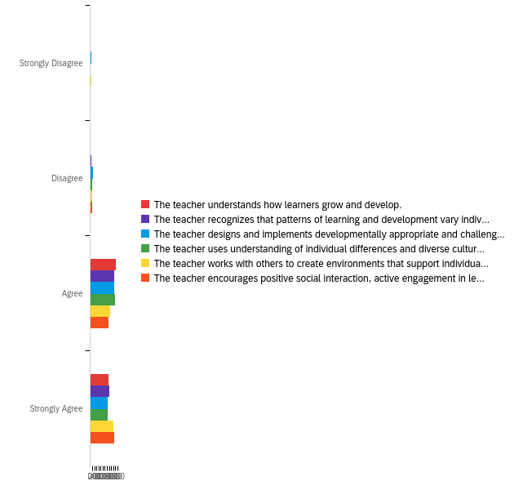

# | Question | Strongly Disagree |  | Disagree |  | Agree |  | Strongly Agree |  | Total
1 | The teacher understands how learners grow and develop. | 1.17% | 5 | 1.17% | 5 | 57.34% | 246 | 40.33% | 173 | 429
2 | The teacher recognizes that patterns of learning and development vary individually within and across the cognitive, linguistic, social, emotional, and physical areas. | 1.40% | 6 | 3.03% | 13 | 53.38% | 229 | 42.19% | 181 | 429
3 | The teacher designs and implements developmentally appropriate and challenging learning experiences. | 1.86% | 8 | 6.06% | 26 | 53.38% | 229 | 38.69% | 166 | 429
4 | The teacher uses understanding of individual differences and diverse cultures and communities to ensure inclusive learning environments that enable each learner to meet high standards. | 1.63% | 7 | 4.66% | 20 | 54.78% | 235 | 38.93% | 167 | 429
5 | The teacher works with others to create environments that support individual and collaborative learning. | 1.86% | 8 | 3.73% | 16 | 43.59% | 187 | 50.82% | 218 | 429
6 | The teacher encourages positive social interaction, active engagement in learning, and self-motivation. | 1.17% | 5 | 4.43% | 19 | 41.49% | 178 | 52.91% | 227 | 429

3. Content Please rate the extent to which you agree that each statement is true of [ExternalDataReference].
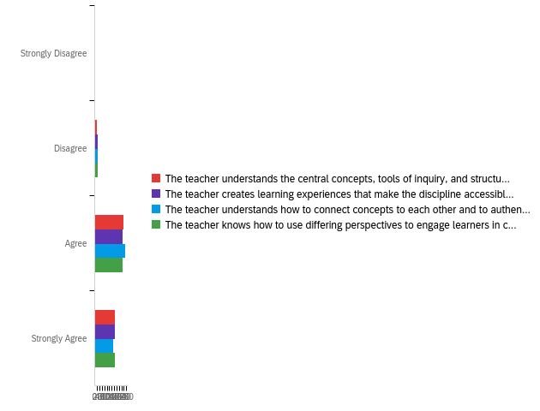

# | Question | Strongly Disagree |  | Disagree |  | Agree |  | Strongly Agree |  | Total
1 | The teacher understands the central concepts, tools of inquiry, and structures of the discipline(s) he or she teaches. | 1.17% | 5 | 4.43% | 19 | 55.24% | 237 | 39.16% | 168 | 429
2 | The teacher creates learning experiences that make the discipline accessible and meaningful for learners to assure mastery of the content. | 1.63% | 7 | 5.59% | 24 | 53.85% | 231 | 38.93% | 167 | 429
3 | The teacher understands how to connect concepts to each other and to authentic local and global issues. | 1.64% | 7 | 5.14% | 22 | 58.18% | 249 | 35.05% | 150 | 428
4 | The teacher knows how to use differing perspectives to engage learners in critical thinking, creativity, and collaborative problem solving. | 1.40% | 6 | 6.53% | 28 | 53.38% | 229 | 38.69% | 166 | 429

4. Instructional Practice Please rate the extent to which you agree that each statement is true of [ExternalDataReference].
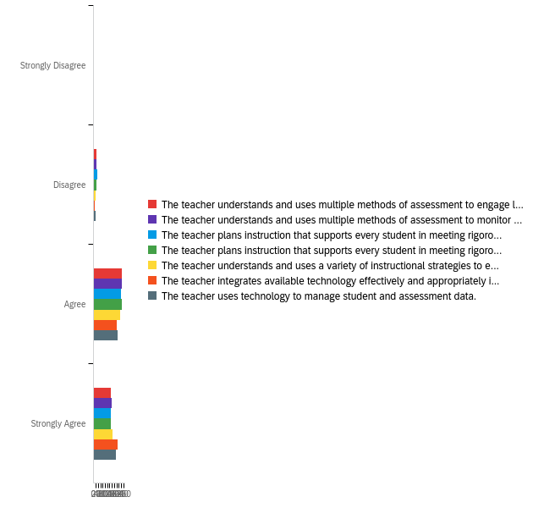

# | Question | Strongly Disagree |  | Disagree |  | Agree |  | Strongly Agree |  | Total
1 | The teacher understands and uses multiple methods of assessment to engage learners in their own growth and guide learners' decision making. | 0.70% | 3 | 6.53% | 28 | 57.11% | 245 | 35.66% | 153 | 429
2 | The teacher understands and uses multiple methods of assessment to monitor learner progress and to guide his/her decision making. | 1.17% | 5 | 5.36% | 23 | 57.11% | 245 | 36.36% | 156 | 429
3 | The teacher plans instruction that supports every student in meeting rigorous learning goals by drawing upon knowledge of content areas, curriculum, cross-disciplinary skills, and pedagogy. | 1.63% | 7 | 7.23% | 31 | 55.94% | 240 | 35.20% | 151 | 429
4 | The teacher plans instruction that supports every student in meeting rigorous learning goals by drawing upon knowledge of learners and the community context. | 1.40% | 6 | 5.83% | 25 | 58.28% | 250 | 34.50% | 148 | 429
5 | The teacher understands and uses a variety of instructional strategies to encourage learners to develop deep understanding of content areas and their connections, and to build skills to apply knowledge in meaningful ways. | 1.40% | 6 | 4.90% | 21 | 54.55% | 234 | 39.16% | 168 | 429
6 | The teacher integrates available technology effectively and appropriately into instruction. | 0.70% | 3 | 2.56% | 11 | 46.85% | 201 | 49.88% | 214 | 429
7 | The teacher uses technology to manage student and assessment data. | 0.70% | 3 | 4.20% | 18 | 49.65% | 213 | 45.45% | 195 | 429

5. Professional Responsibility Please rate the extent to which you agree that each statement is true of [ExternalDataReference].
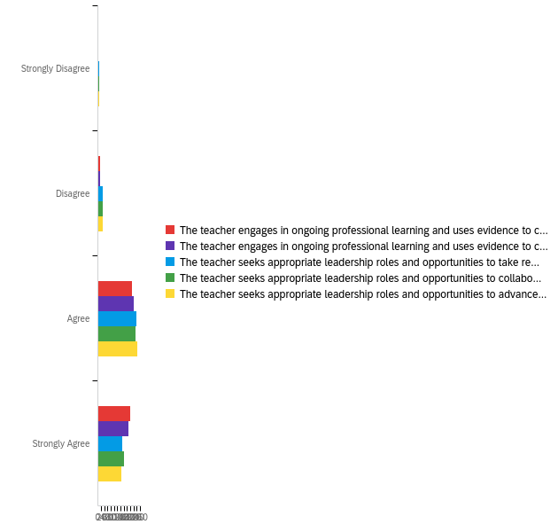

# | Question | Strongly Disagree |  | Disagree |  | Agree |  | Strongly Agree |  | Total
1 | The teacher engages in ongoing professional learning and uses evidence to continually evaluate his/her practice, particularly the effects of his/her choices and actions on others (learners, families, other professionals, and the community). | 1.17% | 5 | 3.26% | 14 | 49.42% | 212 | 46.15% | 198 | 429
2 | The teacher engages in ongoing professional learning and uses evidence to continually adapt practice to meet the needs of each learner. | 1.17% | 5 | 3.26% | 14 | 51.52% | 221 | 44.06% | 189 | 429
3 | The teacher seeks appropriate leadership roles and opportunities to take responsibility for student learning. | 1.40% | 6 | 7.46% | 32 | 55.71% | 239 | 35.43% | 152 | 429
4 | The teacher seeks appropriate leadership roles and opportunities to collaborate with learners, families, colleagues, other school professionals, and community members to ensure learner growth. | 1.63% | 7 | 6.99% | 30 | 54.08% | 232 | 37.30% | 160 | 429
5 | The teacher seeks appropriate leadership roles and opportunities to advance the profession. | 1.86% | 8 | 6.99% | 30 | 57.11% | 245 | 34.03% | 146 | 429

6. Overall, [ExternalDataReference]'s preparation/route to certification effectively prepared him/her to have a positive impact on P12 student learning and development.
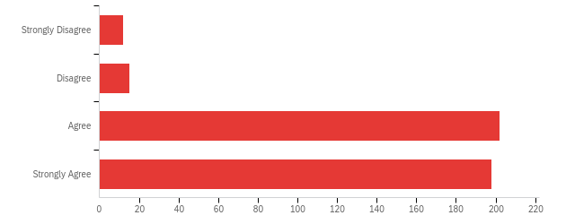

# | Answer | % | Count
1 | Strongly Disagree | 2.81% | 12
2 | Disagree | 3.51% | 15
3 | Agree | 47.31% | 202
4 | Strongly Agree | 46.37% | 198
 | Total | 100% | 427

Q8 - Considering [ExternalDataReference]'s preparation in light of the needs of your school, what are your recommendations for strengthening the teacher's preparation?
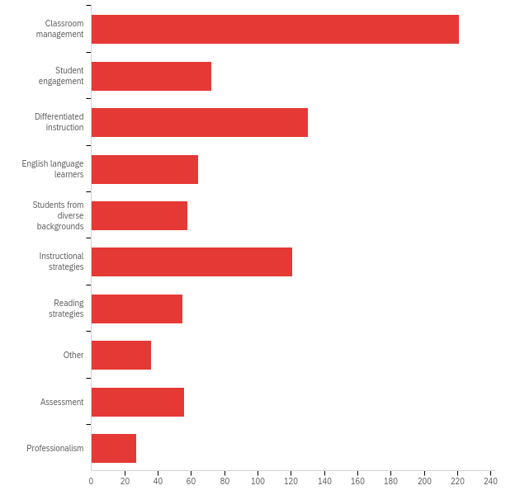

# | Answer | % | Count
1 | Classroom management | 26.31% | 221
2 | Student engagement | 8.57% | 72
3 | Differentiated instruction | 15.48% | 130
4 | English language learners | 7.62% | 64
5 | Students from diverse backgrounds | 6.90% | 58
6 | Instructional strategies | 14.40% | 121
7 | Reading strategies | 6.55% | 55
8 | Other | 4.29% | 36
9 | Assessment | 6.67% | 56
10 | Professionalism | 3.21% | 27
 | Total | 100% | 840

8. [ExternalDataReference] received his/her degree at which of the following institutions? If the teacher has an alternative or emergency certificate, please select Oklahoma State Department of Education.
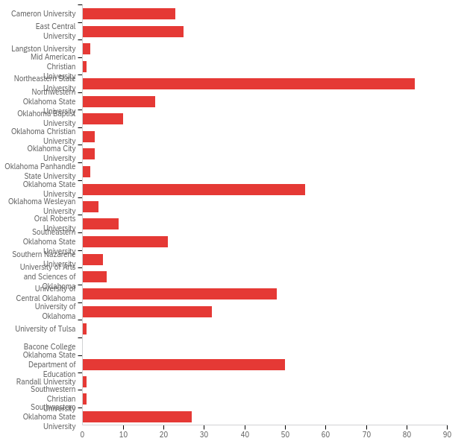

# | Answer | % | Count
1 | Cameron University | 5.36% | 23
2 | East Central University | 5.83% | 25
3 | Langston University | 0.47% | 2
4 | Mid American Christian University | 0.23% | 1
6 | Northeastern State University | 19.11% | 82
7 | Northwestern Oklahoma State University | 4.20% | 18
8 | Oklahoma Baptist University | 2.33% | 10
9 | Oklahoma Christian University | 0.70% | 3
10 | Oklahoma City University | 0.70% | 3
11 | Oklahoma Panhandle State University | 0.47% | 2
12 | Oklahoma State University | 12.82% | 55
13 | Oklahoma Wesleyan University | 0.93% | 4
14 | Oral Roberts University | 2.10% | 9
15 | Southeastern Oklahoma State University | 4.90% | 21
16 | Southern Nazarene University | 1.17% | 5
17 | University of Arts and Sciences of Oklahoma | 1.40% | 6
18 | University of Central Oklahoma | 11.19% | 48
19 | University of Oklahoma | 7.46% | 32
20 | University of Tulsa | 0.23% | 1
21 | Bacone College | 0.00% | 0
22 | Oklahoma State Department of Education | 11.66% | 50
23 | Randall University | 0.23% | 1
24 | Southwestern Christian University | 0.23% | 1
25 | Southwestern Oklahoma State University | 6.29% | 27
 | Total | 100% | 429

9. [ExternalDataReference] received his/her license via:
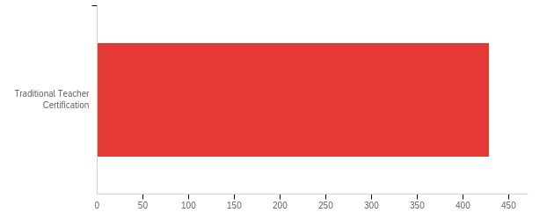

# | Answer | % | Count
1 | Traditional Teacher Certification | 100.00% | 429
 | Total | 100% | 429

10. In what area was [ExternalDataReference] initially certified? (Please check all that apply)
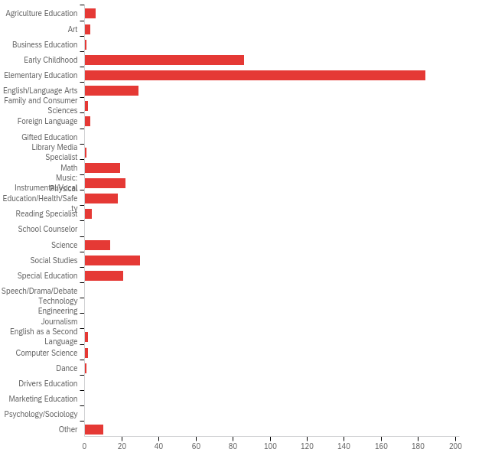

# | Answer | % | Count
1 | Agriculture Education | 1.31% | 6
2 | Art | 0.66% | 3
3 | Business Education | 0.22% | 1
4 | Early Childhood | 18.78% | 86
5 | Elementary Education | 40.17% | 184
6 | English/Language Arts | 6.33% | 29
7 | Family and Consumer Sciences | 0.44% | 2
8 | Foreign Language | 0.66% | 3
9 | Gifted Education | 0.00% | 0
10 | Library Media Specialist | 0.22% | 1
11 | Math | 4.15% | 19
12 | Music: Instrumental/Vocal | 4.80% | 22
13 | Physical Education/Health/Safety | 3.93% | 18
14 | Reading Specialist | 0.87% | 4
15 | School Counselor | 0.00% | 0
16 | Science | 3.06% | 14
17 | Social Studies | 6.55% | 30
18 | Special Education | 4.59% | 21
19 | Speech/Drama/Debate | 0.00% | 0
20 | Technology Engineering | 0.00% | 0
21 | Journalism | 0.00% | 0
22 | English as a Second Language | 0.44% | 2
23 | Computer Science | 0.44% | 2
24 | Dance | 0.22% | 1
25 | Drivers Education | 0.00% | 0
26 | Marketing Education | 0.00% | 0
27 | Psychology/Sociology | 0.00% | 0
35 | Other | 2.18% | 10
 | Total | 100% | 458

11. What is [ExternalDataReference]'s primary teaching assignment? (Please check all that apply)
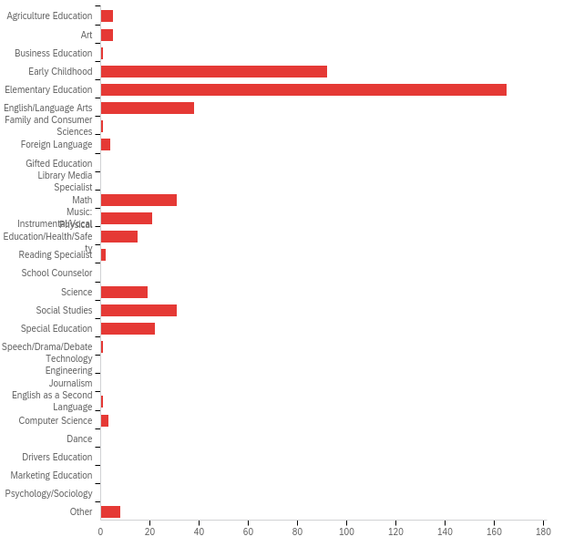

# | Answer | % | Count
1 | Agriculture Education | 1.08% | 5
2 | Art | 1.08% | 5
3 | Business Education | 0.22% | 1
4 | Early Childhood | 19.78% | 92
5 | Elementary Education | 35.48% | 165
6 | English/Language Arts | 8.17% | 38
7 | Family and Consumer Sciences | 0.22% | 1
8 | Foreign Language | 0.86% | 4
9 | Gifted Education | 0.00% | 0
10 | Library Media Specialist | 0.00% | 0
11 | Math | 6.67% | 31
12 | Music: Instrumental/Vocal | 4.52% | 21
13 | Physical Education/Health/Safety | 3.23% | 15
14 | Reading Specialist | 0.43% | 2
15 | School Counselor | 0.00% | 0
16 | Science | 4.09% | 19
17 | Social Studies | 6.67% | 31
18 | Special Education | 4.73% | 22
19 | Speech/Drama/Debate | 0.22% | 1
20 | Technology Engineering | 0.00% | 0
21 | Journalism | 0.00% | 0
22 | English as a Second Language | 0.22% | 1
23 | Computer Science | 0.65% | 3
24 | Dance | 0.00% | 0
25 | Drivers Education | 0.00% | 0
26 | Marketing Education | 0.00% | 0
27 | Psychology/Sociology | 0.00% | 0
35 | Other | 1.72% | 8
 | Total | 100% | 465

